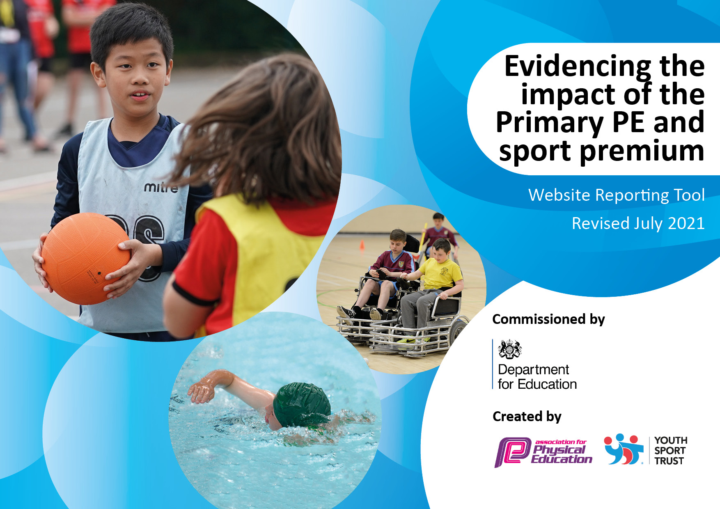
Parklands Primary School
2024-2025

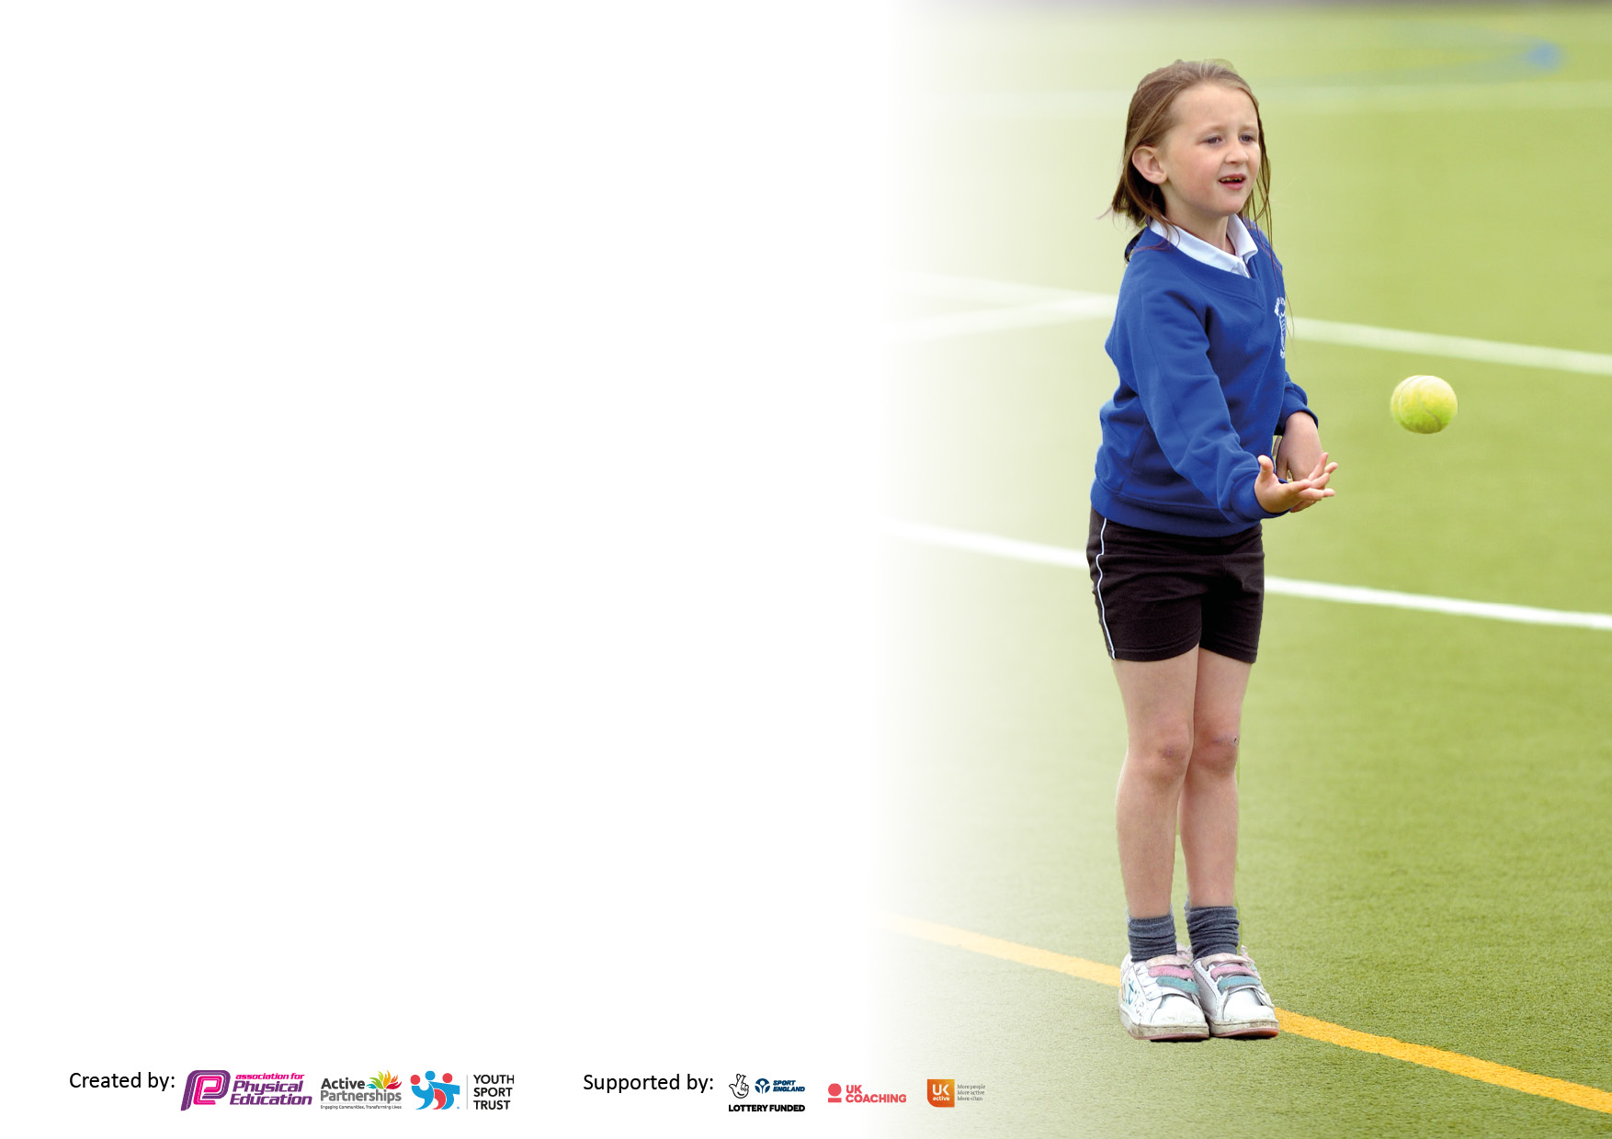
It is important that your grant is used effectively and based on school need. The Education Inspection Framework makes clear there will be a focus on ‘whether leaders and those responsible for governors all understand their respective roles and perform these in a way that enhances the effectiveness of the school’.

Under the Quality of Education Ofsted inspectors consider:
Intent - Curriculum design, coverage and appropriateness
Implementation - Curriculum delivery, Teaching (pedagogy) and Assessment
Impact - Attainment and progress

To assist schools with common transferable language this template has been developed to utilise the same three headings which should make your plans easily transferable between working documents.

Schools must use the funding to make additional and sustainable improvements to the quality of Physical Education, School Sport and Physical Activity (PESSPA) they offer. This means that you should use the Primary PE and sport premium to:

- Develop or add to the PESSPA activities that your school already offer
- Build capacity and capability within the school to ensure that improvements made now will benefit pupils joining the school in future years
- The Primary PE and sport premium should not be used to fund capital spend projects; the school’s budget should fund these.

Pleasevisitgov.ukfortherevisedDfEguidanceincludingthe5keyindicatorsacrosswhichschoolsshoulddemonstrate animprovement.Thisdocumentwillhelpyoutoreviewyourprovisionandtoreportyourspend.DfEencouragesschools to use this template as an effective way of meeting the reporting requirements of the Primary PE and sport premium.

We recommend you start by reflecting on the impact of current provision and reviewing the previous spend.

Schools are required to publish details of how they spend this funding, including any under-spend from 2019/2020, as well as on the impact it has on pupils’ PE and sport participation and attainment. All funding must be spent by 31st July 2022.

We recommend regularly updating the table and publishing it on your website throughout the year. This evidences your ongoing self-evaluation of how you are using the funding to secure maximum, sustainable impact. Final copy must be posted on your website by the end of the academic year and no later than the 31st July 2021. To see an example of how to complete the table please click HERE.


Details with regard to funding
Please complete the table below.

Total amount carried over from 2023/2024 | £0
Total amount allocated for 2024/2025 | £19,190
How much (if any) do you intend to carry over from this total fund into 2025/2026? | £0
Total amount allocated for 2024/2025 | £19,190
Total amount of funding for 2024/2025. To be spent and reported on by 31st July 2025. | £19,190
Swimming Data
Please report on your Swimming Data below.

Meeting national curriculum requirements for swimming and water safety.

N.B. Complete this section to your best ability. For example you might have practised safe self-rescue techniques on dry land which you can then transfer to the pool when school swimming restarts.
Due to exceptional circumstances priority should be given to ensuring that pupils can perform safe self-rescue even if they do not fully meet the first two requirements of the NC programme of study
What percentage of your current Year 6 cohort swim competently, confidently and proficiently over a distance of at least 25 metres?  N.B. Even though your pupils may swim in another year please report on their attainment on leaving primary school at the end of the summer term 2020.  Please see note above | 24%
What percentage of your current Year 6 cohort use a range of strokes effectively [for example, front crawl, backstroke and breaststroke]?  Please see note above | 54%
What percentage of your current Year 6 cohort perform safe self-rescue in different water-based situations? | 100%
Schools can choose to use the Primary PE and sport premium to provide additional provision for swimming but this must be for activity over and above the national curriculum requirements. Have you used it in this way? | No

Action Plan and Budget Tracking
Capture your intended annual spend against the 5 key indicators. Clarify the success criteria and evidence of impact that you intend to measure to evaluate for pupils today and for the future.

Academic Year: 2024/2025 | Total fund allocated: 19,190 | Date Updated:
Key indicator 1: The engagement of all pupils in regular physical activity – Chief Medical Officers guidelines recommend that primary school pupils undertake at least 30 minutes of physical activity a day in school  £5940 |  |  |  | Percentage of total allocation:
 |  |  |  | 30.95%
Intent | Implementation |  | Impact
Your school focus should be clear what you want the pupils to know and be able to do and about  what they need to learn and to  consolidate through practice: | Make sure your actions to achieve are linked to your intentions: | Funding allocated: | Evidence of impact: what do pupils now know and what can they now do? What has changed?: | Sustainability and suggested next steps:
- To ensure lunchtimes provide opportunities for children to be active through a range of different sporting activities.  - Daily mile – on a morning to encourage children to move.  - Maintain ‘active’ after school clubs offered to EYFS/KS1 and KS2 and increasing attendance.  - To ensure an increased percentage of pupils can swim 25m at the end of KS2.  - To target increased swimming 25 metres with LKS2. | - 2 x members from kick start to promote sport two lunch times a week.  - Increase purchase of quality lunchtime sports resources/goals.  - Use PE teachers to supplement and improve quality of lunchtime sports opportunities.  - Increase resources for active lunchtimes using quality resources.  - Year 6 Sports Leaders to create PE games to engage KS1.  - Continue to provide swimming across years 4. | - £400 – Equipment (Sports Premium)  - £560 - Kick Stack company. (Sports Premium)  - £500 swimming.  - £4480 – Extracurricular clubs. | - Since Kick Start came to school, children are showing a great love for football.  - Basketball nets have been purchased and are used at lunch time. | - More sporting opportunities needed at lunch times.  - Ensure daily mile is happening.  - Range of equipment (on different days) to promote different sports.  - Student voice to see interests of different children – to engage all.  - Year 6 sports leaders to be more active with games at lunch times.  - Wake Up/Shake up to commence – Get some year 6 helpers.  - Swimming for Years 4 & 5 from September.  - More active after school clubs.  - New scheme to promote new sports/activities.  - PE equipment is constantly being up dated and this will be continued. Continue to promote the culture within the school community that our school is an ‘Active School’.  - Raise the profile of the importance of PE, school sport and physical activity. Ensuring parents and families know that PE is as important ad any other subject.
Key indicator 2: The profile of PESSPA being raised across the school as a tool for whole school improvement  £6500 |  |  |  | Percentage of total allocation:
 |  |  |  | 38.82
Intent | Implementation |  | Impact
Your school focus should be clear what you want the pupils to know and be able to do and about  what they need to learn and to  consolidate through practice: | Make sure your actions to achieve are linked to your intentions: | Funding allocated: | Evidence of impact: what do pupils now know and what can they now do? What has changed?: | Sustainability and suggested next steps:
- To encourage SEND participation and raised performance for lowest 20%.  - To encourage female participation in sport through the effective use of female role models.  - To continue communicating sporting opportunities through assembly, school newsletters and school website.  - Organise an inclusive sports day, in which all children can achieve.  - To ensure an element of competition during sports day, with teams rewarded for success. | - Teacher to deliver carefully adapted sessions/offers for after school to include SEND, including those with personalised curriculum requirements.  - SEND Sports Events to take place. SEND to take part in sports day.  - SEND to take part in Artis (Boom) sessions.  - Continued communication of sporting opportunities through assembly, school newsletter and school website.  - Letters given out/on class dojo to promote events in the local community.  - PE section on website to display intent, implementation and impact  - Improved resources for events.  - Use school’s sports field/playgrounds to expand physical activities expected during sports day events.  - Medals and trophies for winning children.  - Stickers for children taking part in each race.  - Points on class dojo for children finishing 1st, 2nd & 3rd.  - Sports Leaders/ambassadors established at lunchtimes and for after school.  - Encourage others to participate in a range of activities. | £6500 – Artis/Boom (Sports Premium)  £950 – sports day resources and class dojo rewards (Sports Premium) | - Sports day successful – all children given the opportunity to take part in races/carousel activities. | - Tweak any events for sports day that weren’t successful.  - Clubs focusing on girls interests – do student voice.  - Sportsman/women of the week – in assembly?  - Look into school games  - New scheme to enhance PE  - Sports leaders to have a bigger responsibility at lunch times.  - Sports leaders to set the example in school and discuss the role with the Year 5 children

Key indicator 3: Increased confidence, knowledge and skills of all staff in teaching PE and sport  £1750 |  |  |  |  | Percentage of total allocation:
 |  |  |  |  | 9.2%
Intent | Implementation |  | Impact
Your school focus should be clear | Make sure your actions to | Funding | Evidence of impact: what do |  | Sustainability and suggested
what you want the pupils to know | achieve are linked to your | allocated: | pupils now know and what |  | next steps:
and be able to do and about | intentions: |  | can they now do? What has
what they need to learn and to |  |  | changed?:
consolidate through practice:
- To develop staff confidence with the delivery of PE.  - Staff delivering swimming to be confident in their ability.  - Staff to undergo Forest School Training to deliver these sessions.  - Interschool training and competitions | - Teacher Assistants to work alongside PE Teacher to upskill own expertise in teaching of two key areas of PE (gym and games)  - Staff sent on training  - Staff been on training  - Leeds Learning Alliance | - £500 - Swimming training (sports premium)  - £750 Forest School Training (sports premium)  - £500 |  |  | - New PE strategies to be put in place; potential opportunities for further CPD for staff.  - Provide staff with feedback and check in with further CPD if necessary.  - More active clubs.
Key indicator 4: Broader experience of a range of sports and activities offered to all pupils  £1288 |  |  |  | Percentage of total allocation:
 |  |  |  | 6.7%
Intent | Implementation |  | Impact
Your school focus should be clear | Make sure your actions to | Funding | Evidence of impact: what do |  | Sustainability and suggested
what you want the pupils to know | achieve are linked to your | allocated: | pupils now know and what |  | next steps:
and be able to do and about | intentions: |  | can they now do? What has
what they need to learn and to |  |  | changed?:
consolidate through practice:
- To increase awareness of Ballet through Northern Ballet  - To enable children to develop road safety and active travel (cycling) skills.  - To ensure children have access to sports  - To enable all KS2 children with the opportunity to attend residential experience in Year 4 (in addition to upper Key Stage 2)  - Diwali workshops – all children In school have the opportunity to access a drama workshop. | - Class Teacher accesses CPD through watching Northern Ballet sessions.  - Bikeability to take place in order to ensure all children can ride to school safely. Increased access to all remaining classes this academic year.  - Staff in school to deliver sporting extracurricular sessions. Dance, Football, Drama, Running  - Children have access to a second residential activity in Year 4 to increase access to less accessed skills such as orienteering, high ropes, balance, climbing. | - £200 – Northern Ballet (Sports Premium)  - £200 – Bike Ability- (Sports Premium)  - £4480 – Extracurricular clubs. (mentioned above)  Y4 Residential – Free  Y6 Residential - £10,000  - Diwali workshop - £888 (Sports Premium) | - Northern ballet sessions effective.  - Diwali drama workshop was enjoyed by children. |  | - Identify the impact of who is still least active.  - Identify and provide children with local sports clubs for them to engage.  - After-school clubs / lunch time activities provided based on pupil voice – relevant to each key stage.  - Take into consideration the voice of the children and devise a plan of PE sessions that we cannot provide as a school.  - Provide more extracurricular opportunities.  - Invite more guest speakers into talk to different children/ages.

Key indicator 5: Increased participation in competitive sport |  |  |  | Percentage of total allocation:
Intent | Implementation |  | Impact
Your school focus should be clear | Make sure your actions to | Funding | Evidence of impact: what do | Sustainability and suggested
what you want the pupils to know | achieve are linked to your | allocated: | pupils now know and what | next steps:
and be able to do and about | intentions: |  | can they now do? What has
what they need to learn and to |  |  | changed?:
consolidate through practice:
- Continue to take part in sports day.  - Take part in yearly football competition.. | - Engagement in competition for whole school. |  | - Clear enjoyment from children taking part in sports day. | - Make inter and intra school competitions more common and accessible for all children.  - Increase participation in sporting competitions and festivals accessible to all children.

Key achievements to date: | Areas for further improvement and baseline evidence of need:
- The school provides a broad and inclusive PE/Sport offer through the PE curriculum and an increasingly wide range of extra-curricular clubs.  - The school has provided high quality PE teaching through the use of a specialist PE Teacher, supported by teaching assistants.  - Permanent PE Teachers to provide consistent outstanding provision for PE and widen opportunities for wider curriculum enhancements for PE for all pupils.  - Use of high-quality PE blended curriculum to maintain outstanding levels of physical activity in our curriculum.  - All children have access to an after school clubs.  - The school offers opportunities for sports leadership –  - Active lunchtime physical activity sessions.  - Kick start to promote PE on Mondays and Fridays.  - Permanent PE staff to manage football games.  - Both Y4 and Y6 children participated in school residential.  - PE lessons being taught weekly. | - To further develop opportunities for students to lead within sessions.  - To increase % active sporting opportunities for girls.  - To implement a new PE scheme to ensure a range of sports/skills are being delivered/taught.  - To further develop the skills and knowledge of teachers.  - To consider the development of a Sports Council/Ambassadors in order to help children drive change and improvement throughout school.  - To promote responsibility with sports leaders.  - Encourage staff to offer more/different extracurricular activities.  - To consider a Y6 OAA eg hill walking/mountain climbing (use Well Schools CPD/Health and Safety to train key staff).  - Explore the possibility/costings of leasing a school minibus to allow transport to and from sporting events.  - Attend more local sporting competitions as children need to be given regular opportunity to represent the school.  - Invite guest inspirational speakers – sports for champions,  - Create links with local sporting clubs/centers.  - Target least active  - Pupil voice  - New PE scheme – look at any new resources needed.

Signed off by
Head Teacher:
Date:
Subject Leader: | Miss Rebecca Parker
Date: | 16.07.25
Governor:
Date:

