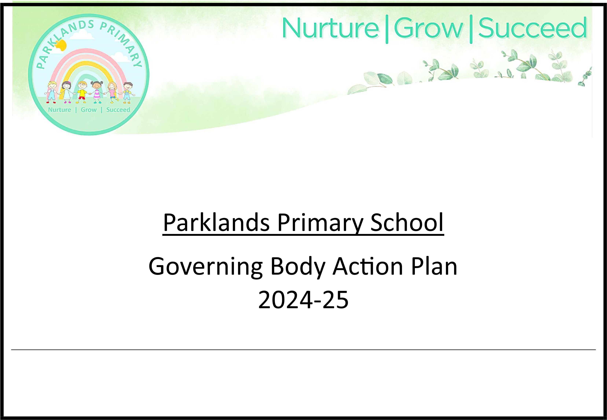
Our purpose as governors:
- Ensuring clarity of vision, ethos and strategic direction;
- Holding executive leaders to account for the educational performance of the organisation and its pupils, and the effective and efficient performance management
of staff;
- Overseeing the financial performance of the organisation and making sure its money is well spent.
The Governing Body of Parklands Primary School aims to:
- provide strategic direction for the school;
- act as a critical friend to the Headteacher and its Leaders;
- ensure accountability;
- support the well-being of pupils, families and staff.
Department for Education: Features of Effective Governance:

- Strategic leadership that sets and champions vision, ethos and strategy.
- Accountability that drives up educational standards and financial performance.
- People with the right skills, experience, qualities and capacity.
- Structures that reinforce clearly defined roles and responsibilities.
- Compliance with statutory and contractual requirements.
- Evaluation to monitor and improve the quality and impact of governance.

Ofsted June 2024
“Outcome: There has been no change to this school’s overall judgement of outstanding as a result of this ungraded (section 8) inspection. However, the evidence gathered suggests that the inspection grade might not be as high if a graded (section 5) inspection were carried out now. The school’s next inspection will be a graded inspection.

◼ The ambitious mathematics curriculum is not implemented well for the most able pupils in key stage 2. As a result, most-able key stage 2 pupils are not achieving as well as they should in mathematics. The school should ensure that its expectations are sufficiently high for the most able key stage 2 pupils in all curriculum subjects, including mathematics.
◼ A small number of pupils have experienced racist bullying. Although the school teaches that this is unacceptable and deal with any incidents swiftly, the incidents continue to happen, and some pupils are unhappy about this. The school should continue to work with parents and pupils to implement its zero tolerance anti-bullying policy.
◼ Pupils’ persistent absence rates are unacceptably high compared to published local and national averages, and by comparison with similar schools. Persistently absent pupils are not receiving their full statutory entitlement to education. As a result, they are not accessing the full curriculum offer and not achieving as well as they should.
The school should continue to analyse attendance data and take appropriate, swift and effective action to reduce persistent absence rates.”

What informs our plan:

Our school vision and values

Mission Statement Nurture - Grow - Succeed.

Our Ethos
At our school we are committed to:
- The safeguarding and wellbeing of all children and adults.
- Enabling every child to make good progress with all aspects of their learning so that they can succeed and find their talents.
- Creating independent, life-long learners who embrace challenge and love their learning.

Identified Priorities for 2025/2026

- To work together to develop our Governing Body so that the school functions efficiently and effectively:
    - Ensure we meet all statutory and legal obligations.
    - Audit the skills of the Governing Body.
    - Further strengthen the Governing Body with suitable appointments.
    - Initiate appropriate training.

- To monitor, challenge and support the School Improvement Plan:
The school improvement priorities are:
    - Improvement Focus 1 - To take part in the Leading SEL: Strengthening Social & Emotional learning in Leeds School project with the EEF.
    - Improvement Focus 2 - To ensure that expectations are high for all children including pupils with SEND/vulnerable in all core subjects. (Please read in conjunction with specific curriculum plans)
    - Improvement Focus 3 - To continue to analyse attendance data and take appropriate, swift and effective action to reduce persistent absence rates.
    - Improvement Focus 4 - To continue to work with parents and pupils to implement its ‘zero tolerance’ anti-bullying policy
    - Improvement Focus 5 - To strengthen Leadership & Governance to Secure Strategic Stability, Raise Outcomes, and Ensure Inspection Readiness

To support the delivery of the school improvement plan, we will
    - Ensure all Governors understand the running of the school and their specific roles.
    - Governors continue dialogue with appropriate staff and demonstrate a greater level of challenge and understanding of the key priorities of the school.
    - With more use of evidence trails, ensuring quality committee meeting minutes and monitoring reports with clear action points.

- The Governors will seek to continue to secure the best possible education for every child at Parklands.
- To ensure that resources are targeted towards school improvement plan priorities.
- To access any additional funding and other support that improves the life chances of our families.
- To ensure that staff well -being and workload is central to key decision making
- To ensure that pupil well-being is a high priority and that mitigating against the impact of CV19 on well-being remains a high priority
- To ensure that the premises are fit for purpose for all learners.

A To work together to develop our Governing Body so that the school functions efficiently and effectively:

Overall Aims
- Ensure we meet all statutory and legal obligations;
- Audit the skills the Governing Body;
- Further strengthen the Governing Body with suitable co-opted appointments;
- Initiate appropriate training.
Success Indicators by end of academic year 2025-26 | Evaluated (Who? When? How?)
1. All governors will have completed a skills audit questionnaire and analysis shared with the board. | - Chair of Governors  - September 2024 - annually
2. A CPD programme will be in place to ensure that governors are up to date with identified and emerging issues. | - FGB  - September 2025 date and ongoing
3. Governors will be appointed to address any gaps in skills and experience. | - Chair of Governors
4. The schedule and agenda of all governor meetings/committees will ensure that all legal requirements are met. From September 2025 the governors will work on a circle model of governance due to the number of new governors. | - Checked by Chair of Governors/ Clerk  - Sept 2025 and ongoing
5. All governors will understand their statutory and legal obligations. | - FGB/ Clerk  - Ongoing

Success  Indicator | Date | Action | Who
1 & 3 | March 2026 | Annual Skills Audit completed | Chair

2 | January 2026 | CPD programme in place - Full schedule of LA governor training for 2024-25 circulated. Appropriate selections made by individuals including Induction courses for new appointments.  Required training schedule checked at Full Governors’ meeting 30 Jan. |  | Chair
4 | Sept 25 | Meeting schedule in place. Reviewed termly. |  | Clerk to Governors
3 | January 2026 | All new governors have either undertaken induction training courses or are scheduled to do so, with some selecting numerous further courses reflecting their allocated specific interests. |  | Chair
3 | September 2025 | The full programme of governor meetings for 2025-26 was agreed. |  | Chair
B To monitor, challenge and support the School Improvement Plan:

Overall Aims
- Ensure all Governors understand the running of the school and their specific roles.
- Governors continue dialogue with appropriate staff and demonstrate a greater level of challenge and understanding of the key priorities of the school.
- Ensure quality committee meeting minutes through more use of evidence trails, and monitor reports with clear action points.
Success Indicators by end of academic year 2025-26 |  |  | Evaluated (Who? When? How?)
1. Meeting minutes indicate that governors have a sound understanding of their legal obligations as governors. |  |  | • FGB minutes
2.Governors have named responsibility for safeguarding, pupil premium, early years, sports premium, SEND, CLA. |  |  | • FGB minutes
3. A planned programme of governor visits is in place. Specific visit overviews are circulated and held on GovernorHub. |  |  | • FGB minutes
4. Governors with a named area or responsibility meet at least twice a year with their named contact at the school. |  |  | • Governor visit reports  • FGB minutes
5. The Chair meets with the Headteacher regularly. |  |  | - HT Report to Governors  - FGB minutes
6. Meeting minutes show that outstanding actions/matters arising are followed up at the next meeting |  |  | • FGB minutes
7. Governors ensure that staff reports to governors are timely and do not create additional workload |  |  | • FGB minutes

Success  Indicator | Date | Action | Who
2, 4, 5 | October 2025 | Specific area responsibilities reviewed and reallocated at October Full Governors meeting. Visiting records to be circulated in line with Visits policy. | All governors
3 | October 2025 | Appoint HT PM Review Panel and schedule program for annual and mid point reviews. | Chair
4 | April/May  2026 | Governors regularly visit the school (see visit log in entrance). They have regular contact with staff leaders in their allocated interest areas. Eg Safeguarding, SEND, RP (at capacity), Early Years, School records. | All governors
4 | May 2026 | Continuing major improvements in school-wide Behaviour evidenced and noted by all. Agreed best ever, due to very specific planning and persistence. | All governors
1 | Sept 2025 | Excellent guidance of legalities/procedures continues to be received from our long-standing external professional Clerk together with several LA specialists. We also benefit from a very knowledgeable and proactive School Improvement Advisor. | All governors

D The Governors will seek to continue to secure the best possible education for every child at Parklands.

Overall Aims
- To ensure that resources are targeted towards school improvement plan priorities.
- To access any additional funding and other support that improves the life chances of our families.
- To ensure that staff wellbeing and workload is central to key decision-making.
- To ensure that pupil wellbeing is a high priority and that mitigating against the legacy of COVID19 on wellbeing remains a high priority.
- To ensure that the premises are fit for purpose for all learners.
Success Indicators by end of academic year 2025-26 | Evaluated (Who? When? How?)
1. Meeting minutes indicate that resources are targeted towards SIP priorities. | FGB minutes
2. Discussions with Local Authority Officers are held as required to further develop the school buildings. | FGB minutes
3. Additional funding and opportunities are secured from a range of sources. These are used to directly improve the life chances of our families. | FGB minutes HT Report to Governors
4. All decisions by governors consider the impact on staff well-being and workload. | FGB minutes
5. Governors survey pupils, staff and parents at least annually. | FGB minutes

Success  Indicator | Date | Action | Who
2 | Continuing | Plans for RP expansion to be debated. Contact with LA ongoing. | FGB
5 | May 2026 | Parent Questionnaire continues the evidence very high levels of approval. | Pupil Supprt
5 | May 2026 | Several governors volunteer to participate in Pupil Voice aimed at evaluating continuous curriculum learning, retention and enthusiasm in main subjects | Volunteers
4/5 | April 2026 | Annual Staff Survey including areas pertaining to wellbeing and workload. | Chair
3 | February 2026 | Meet with School Business Manager to ensure that funding is being accessed where possible. | Chair

