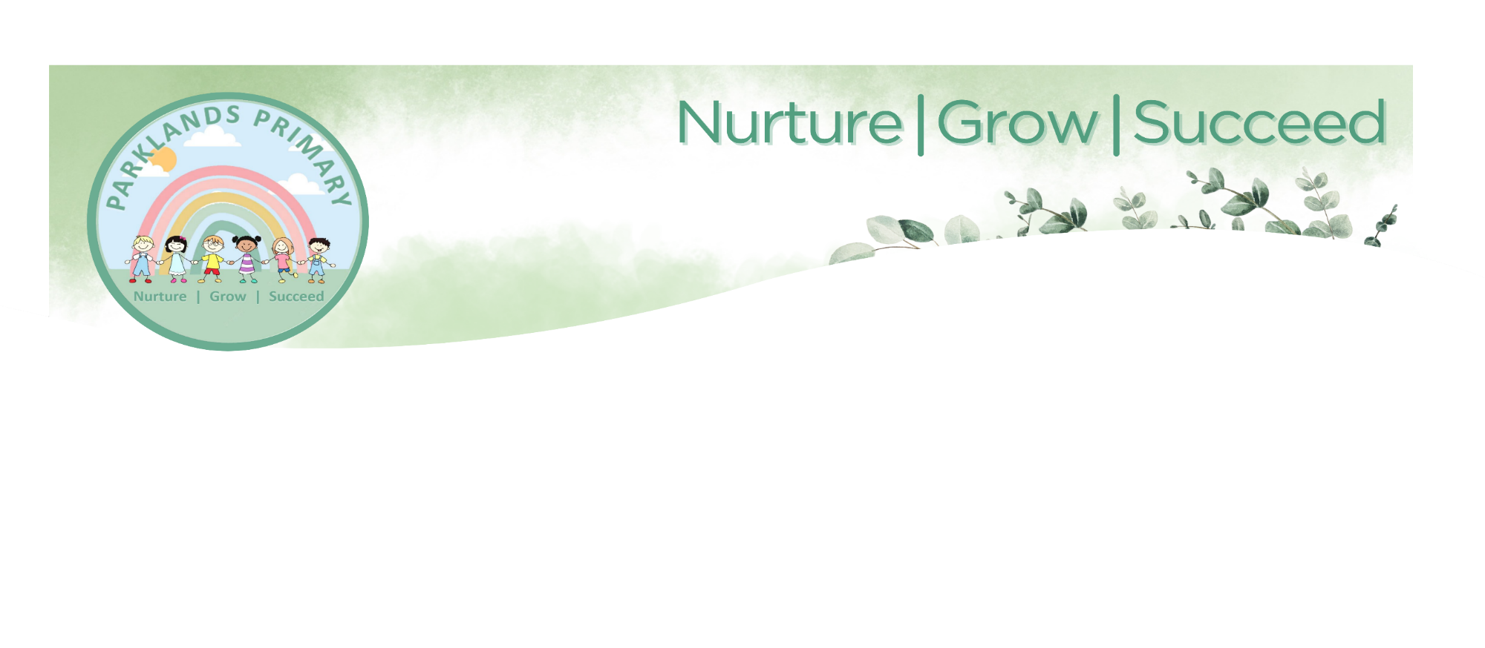

MARKING and FEEDBACK FOR LEARNING POLICY
January 2025 (Review: January 2027)

Our aim at Parklands Primary School is to ensure that all children have their work marked in such a way that it improves their learning, develops self-confidence, raises self-esteem and provides opportunities for self- assessment.

Aims
- At Parklands Primary School we aim to value each child as an individual so that they can develop their potential through an active role in their own learning.
- Provide consistency and continuity in marking throughout the school so that children have a clear understanding of teacher expectations.
- Use the marking system as a tool for formative ongoing assessment.
- Improve standards by encouraging children to give their best and improve on their last piece of work.
- Develop children’s self-esteem through praise and valuing their achievements.
- Create a dialogue which will aid progression.

PRINCIPLES

- To communicate regularly with children about their individual progress.
- To inform the next step in a child’s learning.
- To assist children by setting clear targets to focus on aspects of their work which need further development.
- To motivate children to further effort by raising or celebrating current achievements and raising self-esteem.
- To provide teachers with feedback of how well the children have understood the current work.
- To enable teachers to plan the next step in teaching and learning.
- To help teachers to monitor children’s progress and to diagnose what has not been understood to assist in forward planning.
- To enable the teacher to make judgements about pupils’ attainments particularly relating to teacher assessments within the National Curriculum.
- To inform individual, class and whole school assessment and planning.
- To promote high quality work.
- To develop clarity of purpose.
- To evaluate quality of teaching and learning.
- To encourage reflection and self-improvement.
- To identify if work has errors which children need to correct or if there are misconceptions which need to be addressed by teachers.
- To provide opportunities for questioning which deepens children’s learning.

Learning Objectives

Establishing and sharing the learning objective provides the teacher and pupil with a shared understanding of what the children will achieve during the lesson. Feedback can then be used to move pupils towards this. If the learning objective is achieved it is highlighted green.

Verbal/Oral Feedback
Research shows that verbal feedback is the most powerful form of feedback and has maximum impact when pointing out successes and improvements against learning objectives and success criteria. It is interactive and developmental. It may give reassurance or a check on progress during a lesson or may be in the form of a learning review in a plenary session.

Where work has been verbally discussed, indicate this with VF - verbal feedback has been given. VF is where you give feedback while the child is working and makes an instant difference, thus putting VF on the line/ during the sentence/ in their work.

OF is giving oral feedback at the end of the child's work i.e. to review their completed work and orally explain their next step.

Children respond to oral feedback and verbal feedback by making changes to their work in green pen.

Written Feedback
- Will identify positive aspects of work with a double ticked and annotation in the margin.
- One ‘next step’ to promote learning will be identified through written feedback, which is directly related to that specific piece of work to move learning on. Not every piece of work will have a next step. When it does, it will involve an action for the children to carry out during response time. Actions will be checked by an adult for accuracy.
- A pink highlighter will be used to identify any improvements the child could make focusing on basic principles identified in the SPaG pyramid.
- In Maths, the next step will be either SDI or the challenge.
- Is legible - following the schools Presentation and Handwriting guidance
- Is clear in meaning
- Will show that learning has been met, the learning objective will be highlighted in green.
- Will indicate who is giving the feedback if the person is different to their normal teacher, for example supply staff.
- Will indicate if work has been supported where this wouldn’t be normal for the child. AS for Adult Support or PS for Peer Support.
- Will be appropriate to the age and ability of the child and will vary across year groups and key stages.
- Spelling mistakes will be underlined and sp will be put in the margin where the word will be written correctly. Children will respond to their spellings using the method Look, Cover, Check.
- Pupils will respond to teacher feedback in green pen.

Self-Assessment
- Pupils should be encouraged to identify their mistakes by re-reading their work independently.
- Children should be given a reminder about the focus for checking, linking back to the Learning Objective and success criteria.

Marking Key

Green highlight –learning objective met

Pink highlight – An improvement should be made.

Next steps to move learning on

√√ - identifies excellence in work

Sp in margin and word underlined – spelling to be corrected

I – SEND child has worked independently

PS – peer support given

AS – adult support given

OF – oral feedback given

VF – verbal feedback given

Reviewed date – January 2025

Reviewed by – Sam Rennison Acting Deputy Head

Next Review date - January 2027

