‘Fab 5 Stories’
Reception Story Spine
Term | Autumn 1 | Autumn 2 | Spring 1 | Spring 2 | Summer 1 | Summer 2
Quality Core texts  Chosen for Talk for Writing | 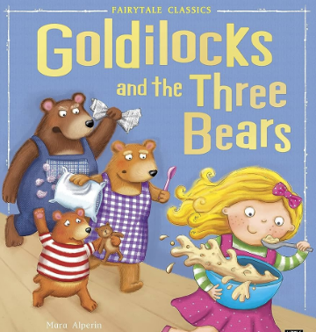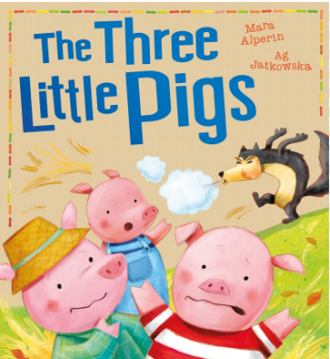 | 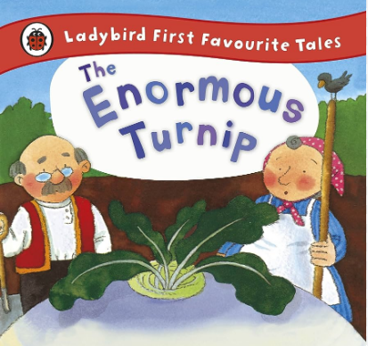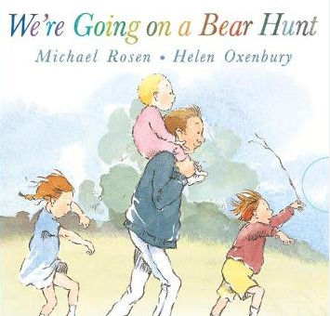 | 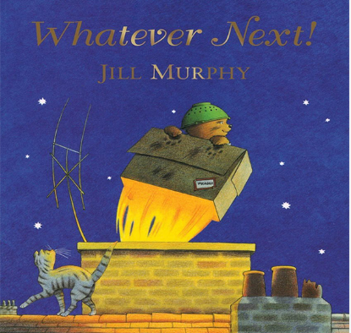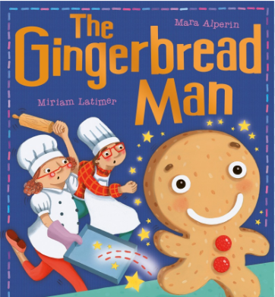 | Non-fiction: Farm recount  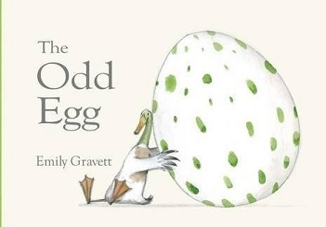 | 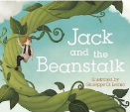  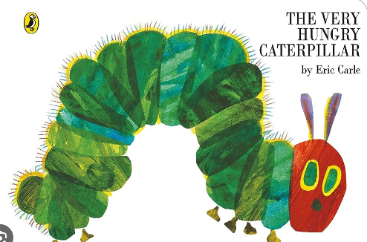 | 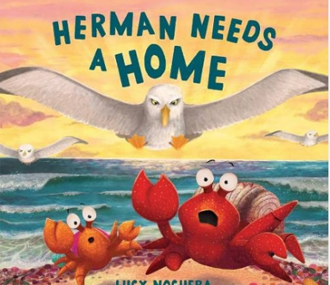
- Old and gold | 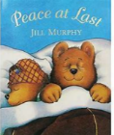 | 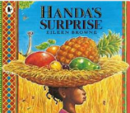 | 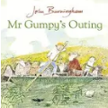 | 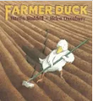 | 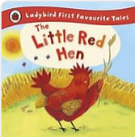 | 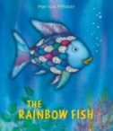
- Rhyming/ repeated refrain | 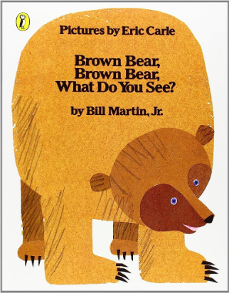 | 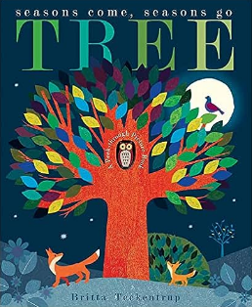 | 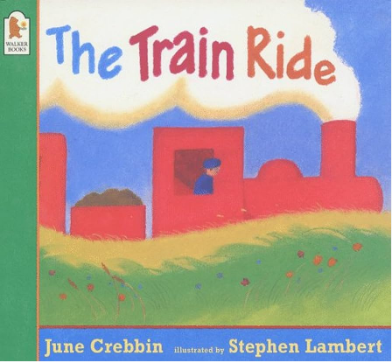 | 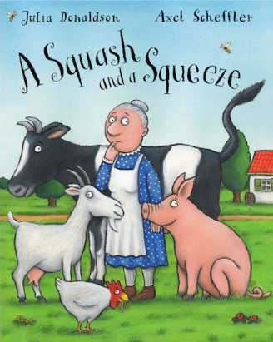 | 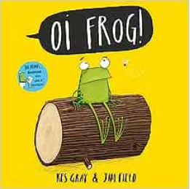 | 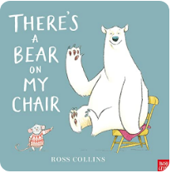
- PSED/ well being | 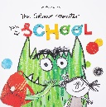 | 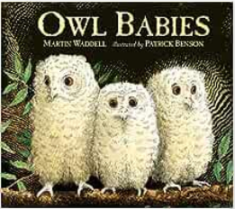 | 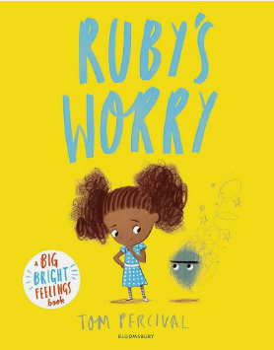 | 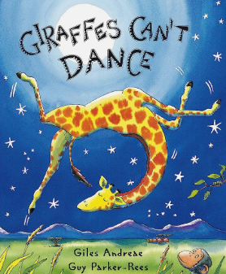 | 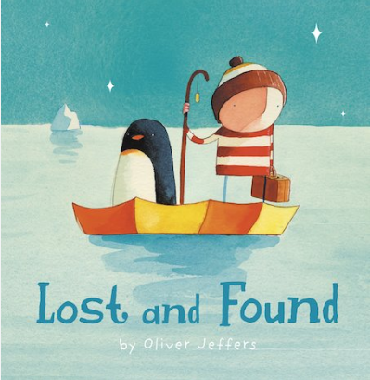 | 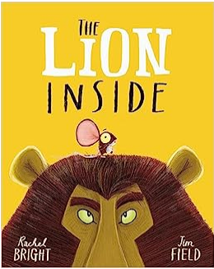
- Diversity (family/ cultural/ religious) | 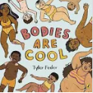 | 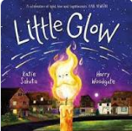 | 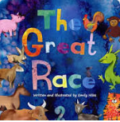 | 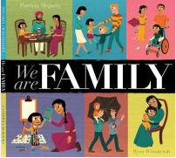 | 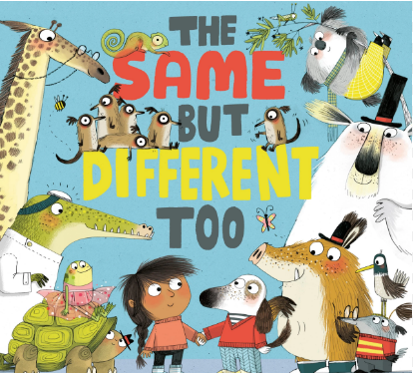 | 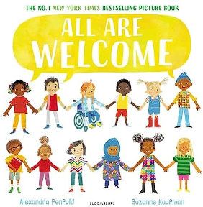
- BAME main character | 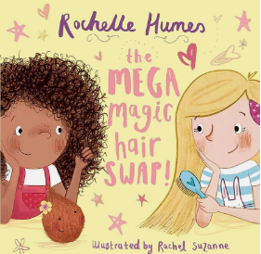 | 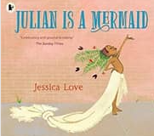 | 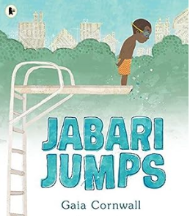 | 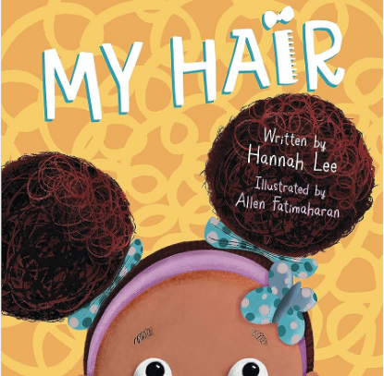 | 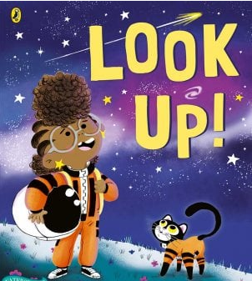 | 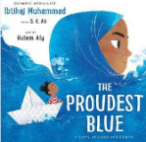

Year 1
Term | Autumn 1 | Autumn 2 | Spring 1 | Spring 2 | Summer 1 | Summer 2
Phonics | Read Write Inc. books and resources
Poetry | Now We are Six – A.A Milne  The Morning Rush –  John Foster | T’was the Night Before Christmas – Clement Clarke Moore  My Shadow – Robert Louis Stevenson | On the Ning Nang Nong – Spike Milligan  The Star – Jane Taylor | Wind on the Hill – A.A Milne  About the Teeth of Sharks – John Ciardi | Aliens Stole My Underpants – Brian Moses  Please do not feed the animals -Robert Hull | Rabbits – Mary Ann Hoberman  The Dentist and the Crocodile – Roald Dahl
Non-Fiction | Topic boxes available in school library
Reading for Pleasure | 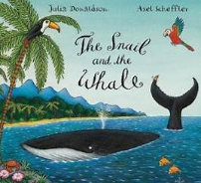  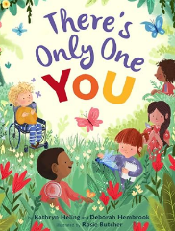  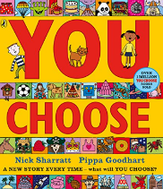  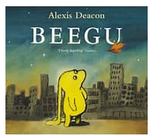  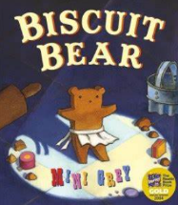  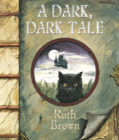  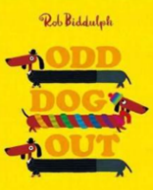  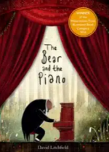  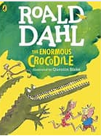 |  | 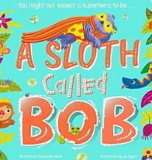  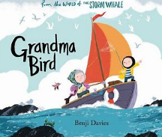  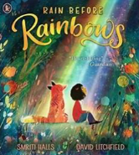  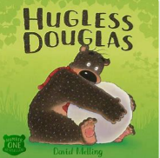  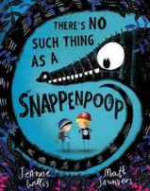  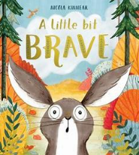  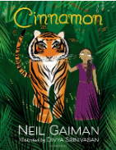  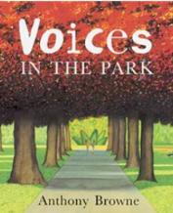  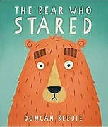 |  | 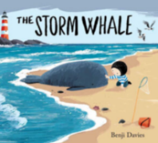  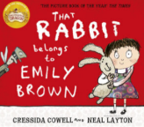  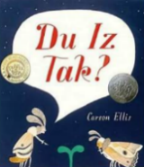  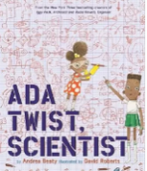  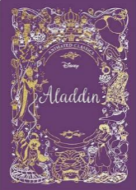  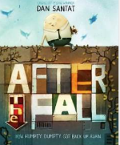  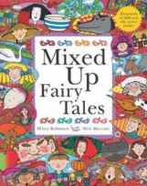  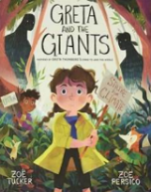  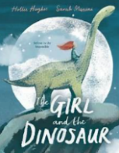
Year 2
Term | Autumn 1 | Autumn 2 | Spring 1 | Spring 2 | Summer 1 | Summer 2
Phonics | Read Write Inc. books & resources
Poetry | The Owl and the Pussycat – Edward Lear  Question Time – Michaela Morgan | Snowball – Shel Silverstein  Heads or Tails? – Kit Wright | If you should meet a crocodile – Christine F Fletcher  What is Pink? – Christina Rossetti | If I Were King – A.A Milne  Grandma’s Glasses – Londis Carpenter | Dad and The Cat and The Tree – Kit Wright  It’s Behind You – David Harmer | Let no one steal your dreams – Paul Cookson  Bed by Summer – Robert Louis Stevenson
Non-Fiction | Topic boxes available in school library
Reading for Pleasure | 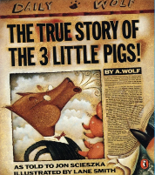  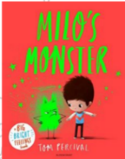  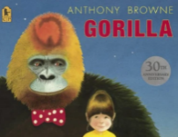  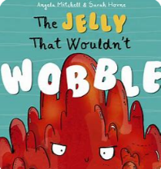  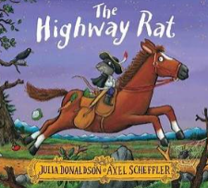  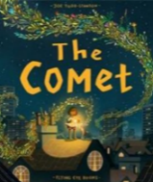  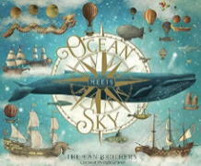  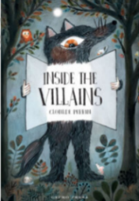  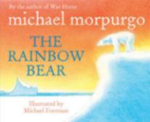 |  | 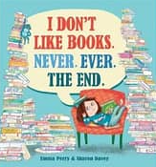  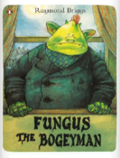  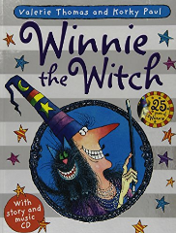  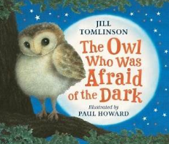  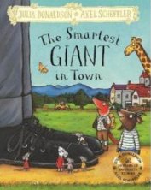  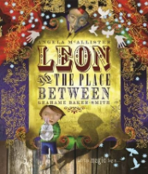  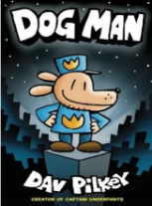  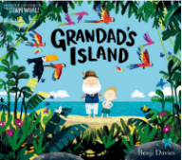  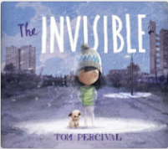 |  | 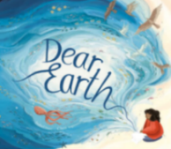  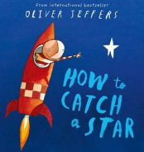  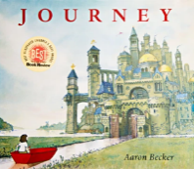    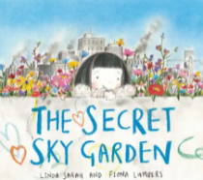  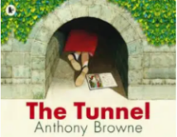  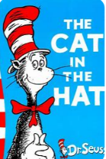  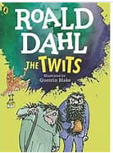  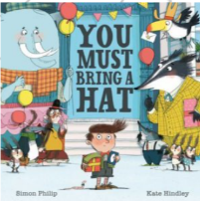
Year 3
Term | Autumn 1 | Autumn 2 | Spring 1 | Spring 2 | Summer 1 | Summer 2
WCR Core Texts | 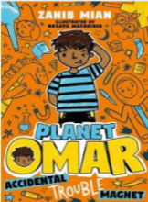 | 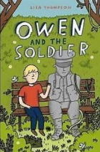 | 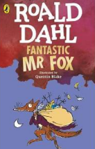 |  | 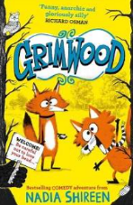 | 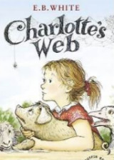
Poetry | Listen to the Mustn’ts – Shel Silverstein  The Sunshine Has a Pleasant Way – Annette Wynne | Please Mrs Butler – Allan Ahlberg  Homework Stew – Kenn Nesbitt | The Eagle – Alfred, Lord Tennyson  Teddy Bear – A.A Milne | The Rainbow – Christina Rossetti  The Quangle Wangle’s Hat – Edward Lear | The Crocodile – Lewis Carroll  The River – Valerie Bloom | Friends – Abbie Farwell Brown  I can’t wait for Summer – Kenn Nesbitt
Non-Fiction | Topic boxes available in school library
Reading for Pleasure - Picture Books | 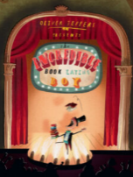  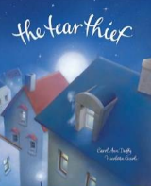  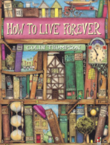  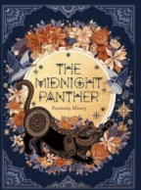 |  | 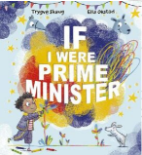  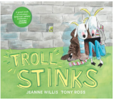  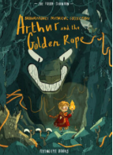  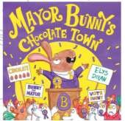 |  | 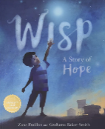  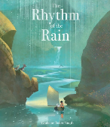  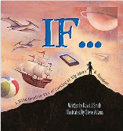  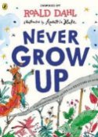
Reading for Pleasure – Book Club promotions during library visits | The Worst Witch – Jill Murphy  Tom Fletcher – The Creakers  The Wild Robot – Peter Brown  Pugs of the Frozen North – Philip Reeve & Sarah McIntyre  Rabbit & Bear – Julian Gough & Jim Field  The Boy Who Grew Dragons – Andy Shepherd & Sara Ogilvie |  | The Accidental Prime Minister – Tom Mclaughlin  The Abominables – Eva Ibbotson  Diary of an Accidental Witch – Pedita & Honor Cargill  The Sheep-Pig – Dick King-Smith  Swop – The Satsuma-Sized Secret.  The Legend of Podkin One-Ear – Kieran Larwood |  | The Worst Class in the World – Joanna Nadin  Call Me Lion – Camilla Chester  The Iron Man – Ted Hughes  The Nothing to See Here Hotel – Steven Butler & Steven Lenton  When the Mountains Roared – Jess Butterworth

Year 4
Term | Autumn 1 | Autumn 2 | Spring 1 | Spring 2 | Summer 1 | Summer 2
WCR Core Texts | 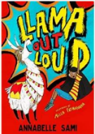 | 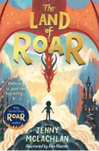 | 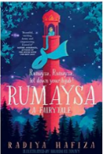 | 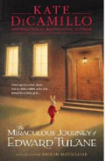 | 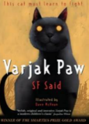 | 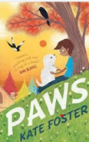
Poetry | From a Railway Carriage – Robert Louis Stevenson  The Mountain and the Squirrel – Ralph Waldo Emerson | Life Doesn’t Frighten Me – Maya Angelou  Dirty Face – Shel Silverstein | Being Brave at Night – Edgar A Guest  Lester – Shel Silverstein | Windy Nights – Robert Louis Stevenson  The Sound Collector – Robert McGough | Elaine the Complainer – Kenn Nesbitt  Alphabet Poem – Edward Lear | Buckingham Palace – A.A Milne  The Vulture – Hilaire Belloc
Non-Fiction | Topic boxes available in school library
Reading for Pleasure - Picture Books | 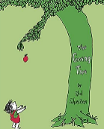  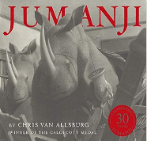  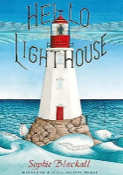  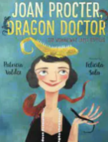 |  | 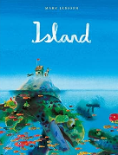  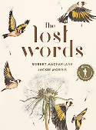  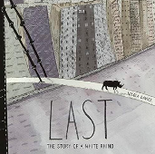  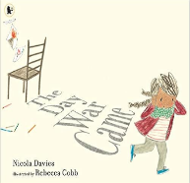 |  | 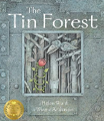  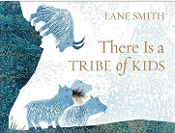  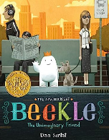  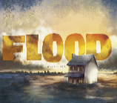
Reading for Pleasure – Book Club promotions during library visits | The Land of Roar – Jenny McLachlan & Ben Mantle  The Girl Who Stole an Elephant – Nizrana Farook  The Queen’s Nose – Dick King Smith  Matilda – Roald Dahl  Race to the Frozen North – Catherine Johnson & Katie Hickey  Toad Rage – Morris Gleitzman |  | Sky – Holly Webb  Magicat – Jennifer Gray, Amanda Swift & Richard Watson  You’re a Bad Man, Mr Gum – Andy Stanton  Krindlekrax – Philip Ridley  The Iron Man – Ted Hughes  Journey to the River Sea – Eva Ibbotson |  | Peter Pan – J.M Barrie  Secrets of a Sun King – Emma Carroll  The Train to Impossible Places – P.G Bell  The One and Only Ivan – Katherine Applegate  Desirable – Frank Cottrell-Boyce  The Boy at the Back of the Class – Onjali Q. Rauf & Pippa Curnick

Year 5
Term | Autumn 1 | Autumn 2 | Spring 1 | Spring 2 | Summer 1 | Summer 2
WCR Core Texts | 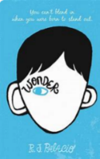 | 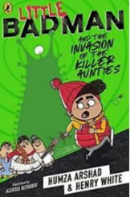 | 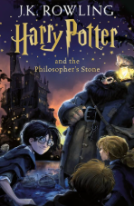  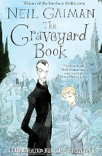 | 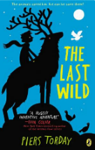 | 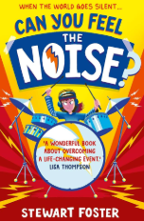 | 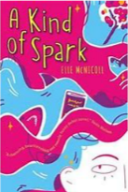
Poetry | Jabberwocky – Lewis Carrol  The Spider and the Fly – Mary Howitt | The Walrus and the Carpenter – Lewis Carroll  Sick – Shel Silverstein | I am angry – Michael Rosen  The Moon – Robert Louis Stevenson | The Oak and the Rose – Shel Silverstein  Night Mail – Robert Louis Stevenson | Macavity: The Mystery Cat – T.S Elliot  My Shadow – Robert Louis Stevenson | Song of the Witches – William Shakespeare  Daffodils – William Wordsworth
Non-Fiction | Topic boxes available in school library
Reading for Pleasure - Picture Books | 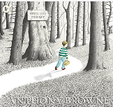  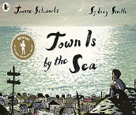  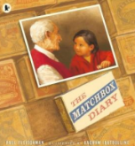  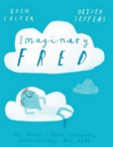 |  | 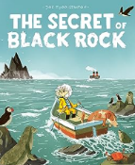  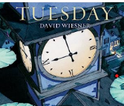  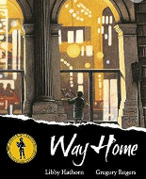  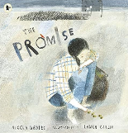 |  | 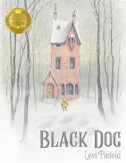  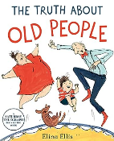  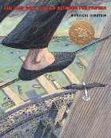  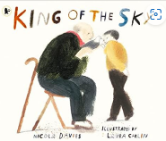
Reading for Pleasure – Book Club promotions during library visits | Alice’s Adventures in Wonderland – Lewis Carroll  The Apprentice Witch – James Nicol  Amari and the Night Brothers – B.B Alston  A Boy Called Hope – Lara Williamson  The Ghost of Thomas Kemp – Penelope Lively  Mary Poppins – P.L Travers |  | Malamander – Thomas Taylor  The Wizards of Once – Cressida Cowell  The Wonderful Wizard of Oz – L. Frank Baum  A Street Dog Named Pup – Gill Lewis  The Storm Keeper’s Island – Catherine Doyle  Sky Song – Abi Elphinstone  Harry Potter & The Philosophers Stone – J. K Rowling |  | The Secret Garden – Frances Hodgson Burnett  Running on the Roof of the World – Jess Butterworth  The Secret of Haven Point – Lisette Auton  Rooftoppers – Katherine Rundell  A Pocketful of Stars – Aisha Bushby  A Girl Called Owl – Amy Wilson
Year 6
Term | Autumn 1 | Autumn 2 | Spring 1 | Spring 2 | Summer 1 | Summer 2
WCR Core Texts | 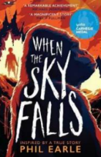 | 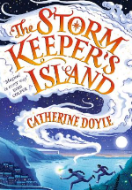  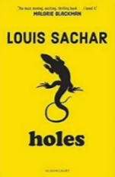 |   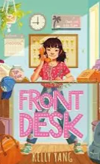 | 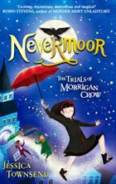  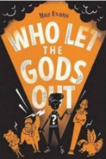 | 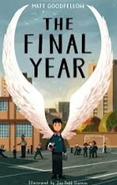 | 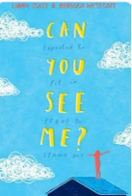
Poetry | Let there be peace – Lemn Sissay  Invictus – William Ernest Henley | The Whatifs – Shel Silverstein  Talking Turkeys – Benjamin Zephaniah | If – Rudyard Kipling  The Road not taken – Robert Frost | Warning – Jenny Joseph  Tyger – William Blake | The Raven – Edgar Allan Poe  The Moment – Margaret Atwood | Ozymandias – Percy Bysshe Shelley  The Listeners – Walter De La Mere
Non-Fiction | Topic boxes available in school library
Reading for Pleasure - Picture Books | 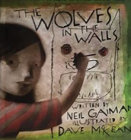  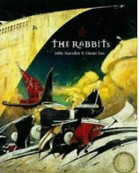  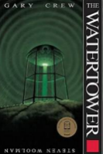  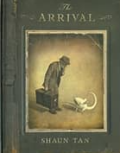 |  | 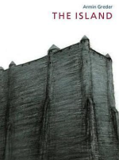  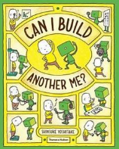  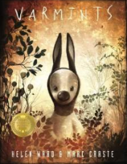  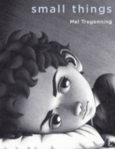 |  | 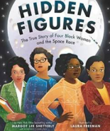  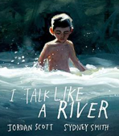  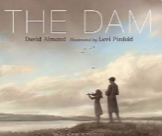  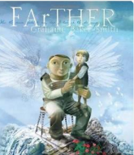
Reading for Pleasure – Book Club promotions during library visits | After the War – Tom Palmer  Cogheart – Peter Bunzel  The House with Chicken Legs – Sophie Anderson  A Christmas Carol – Charles Dickens  Once – Morris Gleitzman  Crater Lake – Jennifer Killick |  | The Railway Children – E. Nesbitt  Letters from the Lighthouse – Emma Carroll  The Midnight Guardians – Ross Montgomery  Stormbreaker Alex Rider – Anthony Horowitz  October October – Katya Balen  Ghost – Jason Reynolds |  | Northern Lights – Philip Pullman  Skellig – David Almond  Tom’s Midnight Garden – Philippa Pearce  Wild Boy – Rob Lloyd Jones  Pax – Sara Pennypacker  Nevermoor: The Trials of Morrigan Crow – Jessica Townsend

